|  |
| --- |
| **HP Pavilion Laptop Cooling Fan** |

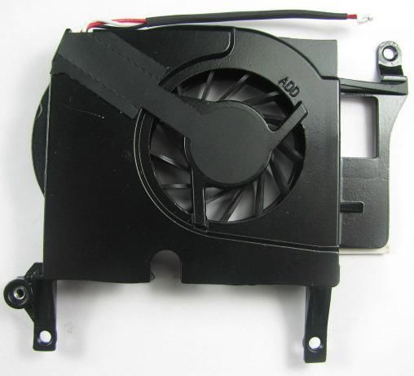

This [HP Pavilion cooling fan](http://www.ebay.com/sch/Computer-Components-Parts-/175673/i.html?_from=R40&_nkw=laptop+CPU+Fans&_pgn=4&_skc=150&rt=nc)offers advanced cooling features for the HP DV6000 Series. All laptop computers can overheat without adequate ventilation. Working on intensive applications will only increase the amount of heat generated inside of the device. However, many laptop computers create too much noise when the [cooling fan](http://www.ebay.com/bhp/cooling-fan?_trkp=i.10000000177715637) attempts to disperse the heat. Loud noises can be problematic for people who often use the computer in public spaces. This CPU cooling fan is incredibly quiet and efficient, and the double outlet feature enhances the qualities of thermoregulation. The original fan normally needs to be replaced periodically. Therefore, it is a good idea to bookmark several pages that show potential replacement items. This can facilitate the replacement process of HP Pavilion cooling fans for any future needs. Checking the laptop model for compatibility before purchasing will reduce the chance of any mistakes.

| **Key Features** |
| --- |
| * Weight of 22 grams * Quiet and light * Compatible with HP DV6000-series laptops |

|  |  |
| --- | --- |
|  |  |
| **HP Probook 4520 Laptop Fan** |  |

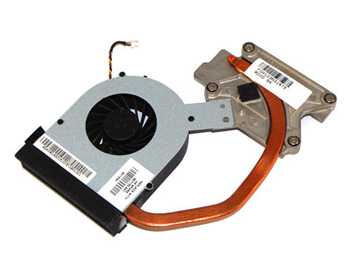

When looking for a top [cooling fan](http://www.ebay.com/sch/Computer-Components-Parts-/175673/i.html?_from=R40&_nkw=laptop+CPU+Fans&_pgn=5&_skc=200&rt=nc), consider the issue of compatibility as well as functionality. There are many different cooling fans for HP Probook laptops, and they should be carefully identified to ensure compatibility. There are over 20 models of the 4520 series of cooling fans for the HP Probook. These are identified by a model number, so always check this number against the manufacturer's recommendations before installation. The 4520 cooling fans can be utilized with UMA subsystems for graphics. The key features enhance the unit's performance by reducing the build-up of internal temperatures. These fans also reduce unwanted noise while maintaining proper ventilation.

| **Key Features** |
| --- |
| * Slender body * Rigorous performance testing * Easy installation |

|  |  |
| --- | --- |
| **3** | **Apple MacBook A1181** |

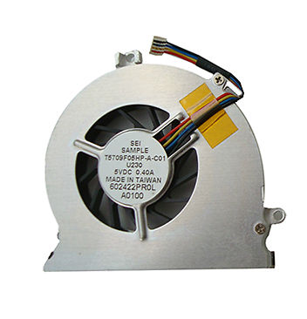

Apple's MacBook laptops are widely used, and this CPU cooling fan is designed to secure the reputation of this line of products. The cooling fan is compatible with the 13-inch MacBook, Apple MacBook A1181 series, and other select MacBook models. This cooling fan is also compatible with the Intel 945 chipset. [Apple laptop](http://www.ebay.com/sch/Computer-Components-Parts-/175673/i.html?_from=R40&_nkw=laptop+CPU+Fans&_pgn=5&_skc=200&rt=nc)cooling fans are vital for maintaining the performance of the system. The slender shape and lightness of the unit helps to maintain the portability of the laptop. The fan is encased in a rotund metallic body with three extruded rings for fastening into place. There are two distinct types of [CPU cooling fans](http://www.ebay.com/sch/Computer-Components-Parts-/175673/i.html?_from=R40&_nkw=laptop+CPU+Fans&_pgn=6&_skc=250&rt=nc)for the Apple MacBook A1181 model, so it is important to compare the part numbers or serial numbers to ensure an exact fit. The unit may or may not come with a heatsink.

| **Key Features** |
| --- |
| * 13-inch series compatible * Easy installation * Excellent performance review |

|  |  |
| --- | --- |
| **4** | **Graphic VGA CPU Laptop Fan Cooler** |

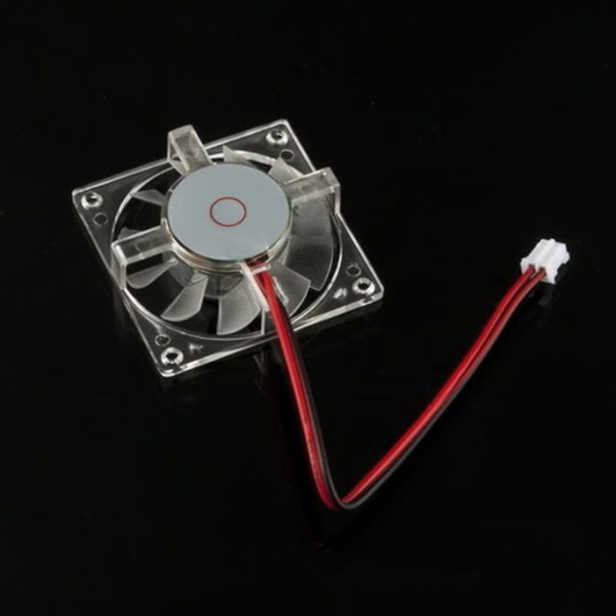

When a laptop uses a [graphics card](http://www.ebay.com/sch/Fans-Heatsinks-Cooling-/42000/i.html?_from=R40&_nkw=laptop+CPU+Fans),, cooling the CPU as well as the graphics card is essential for maintaining the ability of the laptop to perform. Graphics cards can reduce the strain on the CPU during intensive calculations in many cases, but they will also require adequate ventilation in order to function properly. The amount of use and the average environmental temperatures both affect the lifespan of every cooling fan. This CPU cooling unit has a life expectancy of more than 30,000 hours when run within a stable environment. The oil-seal bearing provides lubrication, and the 12-voltage capability reflects the integrity of the design. The thin body of the encasement is designed to maximize airflow, and the four corners have prefabricated sockets for easy installation.

| **Key Features** |
| --- |
| * 11-centimeter cables * PWM speed control * 2-pin connectors |

|  |  |
| --- | --- |
| **5** | **HP G6-2000 Series Laptop Fan** |

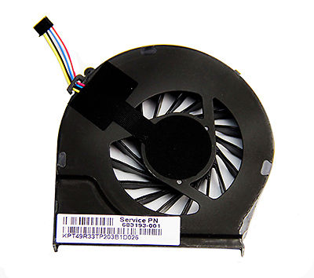

Laptop users are often concerned about the noise generated by cooling fans. This can interfere with audio recordings, and it can also be a nuisance to others. The best [CPU fans for laptops](http://www.ebay.com/sch/Computer-Components-Parts-/175673/i.html?_from=R40&_nkw=laptop+CPU+Fans&_pgn=8&_skc=350&rt=nc)ventilate the system without introducing a lot of noise. The HP G6-2000 CPU fan for laptops proves that cooling down the CPU can be quiet and efficient. This unit has four wires with a four-pin connector, and the 40 millimeter cable provides enough length to ensure ease of installation. The fan has undergone extensive testing in the factory, and the round frame displays all of the relevant parts clearly. The attachment holes for the screws are positioned for stabilization, and the fan blades are shaped to optimize ventilation. This series of cooling fans for Hewlett-Packard laptops extend the life of the device while improving performance.

| **Key Features** |
| --- |
| * 5-volt direct current * Three or four wire models * Rotund frame |